Remixing Projects with Scratch Teacher Accounts

Coding & STEAM 2019

# Introduction

In this activity, you will learn about how you can create tasks for your students and share their projects by combining **Remixing** with the creation of **Class Studios** with **Teacher Accounts**.

Before beginning this activity, we recommend that you complete the *Managing Classes with Scratch Teacher Accounts* activity from the Week 2 session. That activity will walk you through how to perform common tasks with **Teacher Accounts**, such as creating accounts for students, creating **Class Studios** and viewing students’ activity in Scratch.

This activity has three main sections: *Remixing Scratch Projects*, *Creating a Studio for a Remixed Project* and *Remixing a Project as a Student*.

Remixing Scratch Projects: in that section, we explain what **Remixing** is and how this is used in the Scratch community.

Creating a Studio for a Remixed Project: in that section, you will learn how to **Remix** a project and add the project to a **Class Studio** for your students to view and **Remix** from.

Remixing a Project as a Student: in that section, you will log in as one of the student accounts you created and remix the project from the **Class Studio**.

# Remixing Scratch Projects

## What is Remixing?

**Remixing** in Scratch refers to the practice of taking a copy of a Scratch project and making changes to it. In Scratch, you can use the **remix** button to copy all of a project’s Sprites and blocks. You can see the **remix** button after clicking the *See Inside* button on a project page to open the Scratch editor, as shown below:



The Scratch Wiki has a [page on Remixing in Scratch](https://en.scratch-wiki.info/wiki/Remix), which explains how you can remix a project and some of the potential issues with ****remixing**** in the Scratch community (such as plagiarism of others’ work). You will also learn more about **remixing** in future sessions.

# Creating a Studio for a Remixed Project

In this section, you will learn how to create a **Class Studio** for a **Remixed** project. We have two examples of where you might want to use **Remixing** with **Class Studios.** First, this approach could be useful when setting a task for your students to complete that involves fixing (**Debugging**) a project. Second, this approach could also be useful when you ask students to find existing projects on Scratch and to make their own changes to them.

In this activity, we will focus on the use of **Class Studios** and **Remixing** for setting up a **Debugging** task for your students to complete. The **Debugging** task will be remixed from one of the “Debug It!” activities created for the *Creative Computing Curriculum Guide*.

## Creating a Studio for a Task

To create a **Class Studio**, you must be logged into your **Teacher Account**. We also recommend that you have created some **Classes** and **Student Accounts** already**,** as explained in the *Managing Classes with Scratch Teacher Accounts* activity from Week 2 of the program.

In this part of the tutorial, you will create a **Class Studio** for the “Debug It! activity.

You can create a **Class Studio** from the *My Classes* page. You can get to the *My Classes* page from the link in the menu at the top-right of the Scratch homepage, as circled in red in the image below:



In the image below, you can see the information for the *Stage 3* class that I have selected on the *My Classes* page. That class currently has no **Class Studios,** as can be seen by the *Studios (0)* link. Click on the *Studios (0)* link on one of the classes that you have created, so that you can see all of the **Class Studios** for that class.



You may already have some **Class Studios**, so your *Studios* tab might look different to the image above. Next, click the *“+ New Class Studio”* buttonand to create a new **Class Studio** titled: *Unit 1 Debug It! Task 1.*

After creating the new **Class Studio**, the *Studios* tab should look similar to the image below:



Now that you have created the **Class Studio**, the next steps will walk you through **remixing** the activity that will be added to the Studio.

## Remixing a “Debug It!” Activity

The activity that you will be **remixing** is from a Studio of existing projects on the Scratch website. The Studio can be viewed by going to this website address: <https://scratch.mit.edu/studios/475483/projects/> Alternatively, you can get to this Studio by using the *Creative Computing Unit 1: Debug It! Studio* link on the Week 2 session page, which is under the *Assessing Coding Links* heading.

The *Unit 1 Debug It!* Studio contains 5 projects that don’t work properly and need to be fixed. You can ask your students to try and fix these projects (by **Debugging**), which could be a useful and quick way to check your students’ understanding of different Coding concepts in Scratch. In this activity we will look at the first “Debug It” – the project that is called *Debug-It 1.1*.

After going to the website address above, you should see a Studio that looks similar to the image below. You should click the *Debug-It 1.1* project, circled in red, to go to that project’s page.



After clicking on the project, you will be taken to the *Debug-It 1.1*. project page. You can **remix** a project from the project page or from within the editor view (where you can see the Sprites and Code Blocks). For this activity, you can **remix** the project from the project page, by clicking the **remix** button in the top-right of the screen, as circled in red in the below image:



After clicking the **remix** button, you may notice the project’s name (at the top-left of the screen) will change to *Debug-It 1.1 remix*. By clicking the **remix** button, you have created a copy of the project and can make your own changes to it, without affecting the original project.

When you **remix** a project, it will not be shared automatically and consequently it will not be able to be viewed by your students. In the next steps, you will learn how to share the project and add it to the **Class Studio** you created in the previous steps, so that your students can **remix** the task.

## Adding the Remixed Activity to a Studio

In this part of the activity, you will add the **remixed** project to the **Class Studio** that you created in Section 3.1 of this activity.

Before adding the project to the **Class Studio**, you have to **share** the project. To do this, click the **Share** button at the top-right corner of the editor, as circled in the red below:



You can add a project to a **Class Studio** from the project page for the **remixed** project. To get to the project page, click on the **See project page** button, as circled in red in the image below:



Once the project page loads, you can add the **remixed** project to the **Class Studio** by first clicking the **Add to** **Studio** button, as circled in red in the image below:



By clicking that button, you get a list of Studios you can add the project to. Click the button next to the *Unit 1 Debug It! Task 1* and the project will be added to the **Class Studio**, as indicated by the green label and tick, as shown in the below image, then click the **Okay** button.

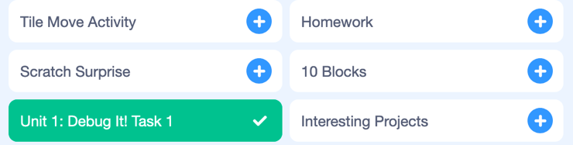

After adding the *Debug-It 1.1 remix* project to the **Class Studio,** that project will now appear in the Studios tab for that Class, on the *My Classes* page. An example of this is shown in the image below:

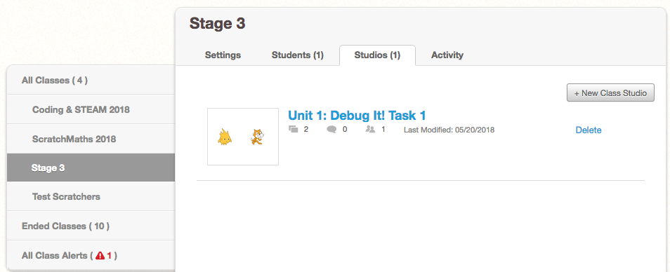

Now that you have **remixed** the “Debug It” project and added it to the **Class Studio**, you will now learn about the steps your students would have to follow to **remix** and complete the task.

# Remixing a Project as a Student

When your students complete the task, they will also have to **remix, share** and add the project to the **Class Studio**. In this part of the activity, you will learn how to complete these steps when logged into one of your student’s accounts.

To complete these steps, you will have to be logged into a student account that is part of the **Class** that you created the **Class Studio** for. In this activity, the account that we used when writing the tutorial is called *Stage3_Boy*, which is a student of the *Stage 3* **Class**.

To sign out of your account, you can click on the menu at the top-right of the screen and click the *Sign Out* link that is circled in red in the image below:



After signing out of your **Teacher Account**, log into one of your student’s accounts.

## Finding the Class Studio with the Task

When logged into a **Student Account**, you can see all of the **Class Studios** from the *My Class* page. To get to the *My Class* page, you can click on the *My Class* through the menu at the top-right of the screen, as circled in red in the image below:



After clicking on that link, you will be able to see the *My Class* page for the class that you created. You can see the **Class Studio** that has been created in the previous steps, circled in red, in the image below:



Next, you should click on the *Unit 1: Debug It! Task 1* **Class Studio**to view the Studio with the “Debug It!” activity in it. After clicking on that **Class Studio**, you will see a similar view to that shown below.



## Remixing the Project

After you have found the **Class Studio** with the “Debug It!” activity in it, you will be able to **remix** the project. To do this, click the project that you **remixed** with the **Teacher Account**, circled in red below:



Clicking that project will take you to the project page for the *Debug-It 1.1. remix* project. From the project page, you can **remix** the project by clicking the **remix** button that is circled in red in the image below.



After clicking the **remix** button, you may notice that the project name has changed to *Debug-It 1.1. remix remix*, which indicates that this is a **remix**of the **remixed** project from Section 3.2 of this activity.

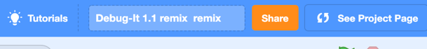

## Sharing the Project

The **remixed** project has to be shared before it can be added to the **Class Studio**. To do this, you can click the **Share** button at the centre at the top of the screen, as circled in red in the image below:



Once the project is shared, you will be able to add the project to the **Class Studio** you created earlier.

## Adding the Project to the Class Studio

To add the project to the **Class Studio**, you will first have to go to the project page. After sharing the project, you may automatically be taken to the project page. If you are not taken to the project page automatically, click the **See project page** button at the centre at the top of the screen, as circled in red in the image below:



After clicking the **See project page** button, you will see the student’s copy of the **remixed** “Debug It!” project, as shown below. You can add the project to the **Class Studio** using the same approach you used in Section 3.3 of this activity. Click the **Add to Studio** button, which is circled in red in the image below: 

When you click the **Add to** **Studio** button, as shown in the image above, you will see a list of the **Class Studios** you can add the project to. Click the button next to the *Unit 1: Debug It! Task 1*, so that the student’s project is added to that **Class Studio** you created and click **Okay**.

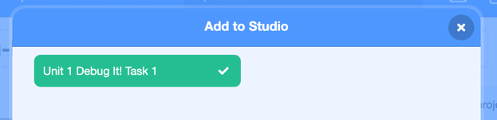

Now the student’s copy of the “Debug It!” activity will also be in the **Class Studio** you created, as shown in the example image below:

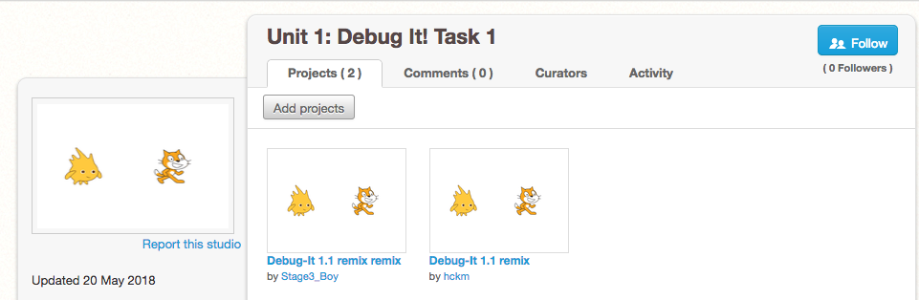

The *Unit 1: Debug It! Task 1* **Class Studio** now has the copy created by the student (*Stage3_Boy)* and the copy created by the teacher (*hckm)*. If you had each of your students add their copy to this **Class Studio** you would be able to see the approaches that each of the students used to try and fix the “Debug It!” project.

## 4.5 Fixing the Debug It! Project

Now that you have you remixed the project with a **Student Account**, try and fix the problem in the “Debug It!” task.

As explained in the project’s description, when the green flag is clicked, the Cat Sprite begins to dance. However, Gobo (the yellow spiky Sprite) does not begin to dance. Have a look at the Code inside the project (by using the **See inside** button on the project page) and see if you can figure out why Gobo does not dance and how to make him dance when the green flag is clicked.

Hopefully you find the solution and can fix the project. If you cannot find the solution, please let us know and we will help you find the solution.

# Conclusions

In this activity, you learned how to create tasks for your students and share their projects by combining **Remixing** with the creation of **Class Studios** with **Teacher Accounts**.

This activity had three main sections:

* *Remixing Scratch Projects*
* *Creating a Studio for a Remixed Project*
* *Remixing a Project as a Student*

You could use the approaches in this activity to help you manage students’ projects, such as when setting assessment tasks or asking them to complete “Debug It!” activities.

This activity will be available indefinitely on the program website for you to review during or after the Coding & STEAM 2019 program. To find out more information about **Teacher Accounts** we recommend that you review the *Managing Classes with Scratch Teacher Accounts* activity on the Coding in Stage 3 website and [the Scratch Teacher Account FAQ on the Scratch website](https://scratch.mit.edu/educators/faq).